What I changed in the Model and Why

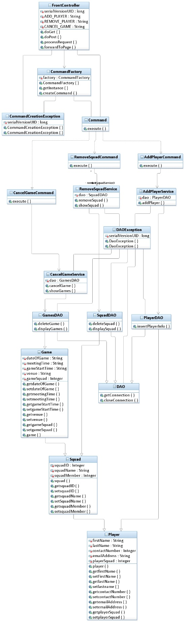

What I Changed and Why

1. I now have a directed association between AddPlayerService and squadDao to access the show squad method so that we can get a list of the squad data and it can be used to display the squads on the html which is in turn used to add the squad ids as the foreign key.
2. I have removed the squadmember attribute because I believe a many to 1 relationship would suffice.